FOREST HOUSE MEDICAL CENTRE & WARREN LANE SURGERY

2a Park Drive
L.F.E.
Leicester LE3 3FN
Tel: 0116 2898111, web: www.foresthousemedicalcentre.co.uk
Thank you for applying to join Forest House Medical Centre & Warren Lane Surgery. We would like to gather some information about you and ask that you fill in the following questionnaire. Please supply two forms of Identification with your completed form, a photographic form of ID (such as a passport or driving licence) and proof of your home address (such as a recent bank statement or document relating to your new home)
Please note if you do not complete the form fully you may not be able to register

Please complete all areas in CAPITAL LETTERS and tick the appropriate boxes.

Title | Surname |  | First names
Any previous surname(s) |  |  | Date of Birth
Male Female |  |  | NHS No.
Town and country of birth |  |  | Home address
Home telephone No.
Work telephone No. |  |  | Postcode
Mobile No. (if you have one) |  |  | Email address
Previous address Previous GP details
Previous address in the UK |  |  | Name of previous doctor while at that address
 |  |  | Address of previous doctor
Postcode

If you are from abroad
Your first UK address where you registered with a GP if you were previously living abroad |  | If previously a resident in the UK,  date of leaving
 |  | Date you first came to live in the UK if applicable
Postcode

Were you ever registered with an Armed Forces GP
These questions are optional, and your answers will not affect your entitlement to register or receive services from the NHS but may improve access to some NHS priority and service charities services.

Please indicate if you have served in the UK Armed Forces and/or been registered with a Ministry of Defence GP in the UK or overseas:
Regular Reservist Veteran Family Member (Spouse, Civil Partner, Service Child)

Address before enlisting |  | Service or Personnel No.
Enlistment date
Discharge date
Postcode

*Main languages
English
Other (please specify)
Interpreter required?
Yes | No

*What is your ethnic group? (Please circle the option that best describe your ethnic group or background)
White |  | English/Welsh/Scottish |  | Northern Irish |  | Irish
Black |  | Caribbean |  | African |  | Other
Asian |  | Indian |  | Pakistani |  | Chinese
Mixed |  | White + Black Caribbean |  | White + African |  | White + Asian
Other Please specify:

Do you have any additional communication requirements? i.e. Braille, Large Print ……………………………………………
(staff to code XaIKS if any needs identified)

Do you have a Carer? Yes No
If yes, what is their name and contact number?
Do you consent for your carer to be informed about your medical care? Yes No

Are you a Carer? Yes No
If yes, do you look after someone who is a patient of this Surgery? Yes No Don’t know
If yes, what is their name?
Are they a: Relative Friend Neighbour

Are you an Adult with social care involvement?  Yes No | If yes, please state the reason why
Do you have a nominated patient advocate/advocacy service or Lasting Power of Attorney?
Yes No

Details ……………………………….

Next of kin
Name of next of kin |  | Relationship to you

Next of kin telephone number(s) |  | Next of kin address (if different to above)

Please attach any repeat medication you have on a regular basis.

Medical details

Height ft in |  | (For women only) Have you had a cervical smear?  Yes No (Please state where, when and the result if possible)
Weight st lb

Waist measurement in

Is anybody else in the household already registered at this practice, if so, please provide their name & d.o.b. below  ……………………………………………………………………………………  …………………………………………………………………………………… |  | Do you consent to receive emails, text messages and answering machine messages from the Surgery? Yes No
If over 18 please provide recent BP reading. This can be taken on one of the practice machines at Warren Lane
BP reading :

If BP > 140/90 please arrange 7 day BP reading at reception

Are you allergic to any medicines? Yes No (if yes please specify)

List other allergies (pollen, animal hair or certain foods. Please mark “none” if you have no other allergies that you know of)

Do you wish to nominate a pharmacy for prescriptions to be sent electronically?
If yes, please enter the pharmacy you wish to nominate ……………………………………………………………………
(Please ask at reception for further information)

Have you ever had any of the following conditions?
Epilepsy | Yes | Year |  | Mental Illness | Yes | Year
High Blood Pressure | Yes | Year |  | Diabetes | Yes | Year
Heart Attack / Angina | Yes | Year |  | Asthma | Yes | Year
Stroke / Mini stroke (TIA) | Yes | Year |  | COPD (or Emphysema) | Yes | Year
Cancer | Yes | Year |  | Osteoporosis / Bone fractures | Yes | Year
Rheumatoid Arthritis | Yes | Year |  | Peripheral vascular disease | Yes | Year

List any serious illnesses / operations / accidents / disabilities (women: any pregnancy related problems) & the year they took place

Do you have family history of any of the following?
High Blood Pressure | Yes | Who |  | DVT / Pulmonary Embolism | Yes | Who
Ischaemic Heart Disease  Diagnosed aged >60 yrs | Yes | Who |  | Breast Cancer | Yes | Who
Ischaemic Heart Disease  Diagnosed aged <60 yrs | Yes | Who |  | Any Cancer  Specify type: | Yes | Who
Raised Cholesterol | Yes | Who |  | Thyroid disorder | Yes | Who
Stroke / CVA | Yes | Who |  | Epilepsy | Yes | Who
Asthma | Yes | Who |  | Osteoporosis | Yes | Who

Please tell us about your smoking habits
Do you smoke? Yes No  If yes, what do you primarily smoke:  Cigarettes / Cigar / Pipe (please circle) |  | Are you an ex-smoker Yes No  When did you quit?  How many did you used to smoke a day?
How many do you smoke a day?
Would you like advice on quitting? Yes No

NHS Organ Donor registration

On 20 May 2020, the law around organ donation in England was changed to allow more people to save more lives.

Now that the law has changed, it will be considered that you agree to become an organ donor when you die, if:
you are over 18.
you have not opted out.
you are not in an excluded group.

You still have a choice whether you want to become an organ donor and can register or amend your decision at any time.
To register your decision log in to your NHS App and amend your choice or please visit www.organdonation.nhs.uk.

*Signed |  | *Date (dd/mm/yyyy) / /

Signed on behalf of patient (if applicable) Full Name:
(Minors under 16 years old, adults lacking capacity)
Relationship:

Data Sharing

Summary Care Record (SCR)
The SCR is a basic summary of your medical history that can be shared between healthcare staff treating patients in an emergency or out-of-hours with faster access to key clinical information. This includes recent medication, any allergies & adverse reactions. More information can be found by visiting www.nhscarerecords.nhs.uk

Do you consent to the Summary Care Record (SCR)? Yes No

Do you consent to the Enhanced Summary Care Record (this will include as above plus a more detailed summary of your medical history including e.g. immunisations, major diagnoses & long term conditions? Yes No

Medical Interoperability Gateway (MIG)
Whilst the SCR mentioned above shares a very small portion of your medical record across the whole NHS, the MIG shares a much fuller view of your records but only with local NHS providers – and only when you give explicit consent at the point of care.

Tick this box if you wish to opt-out of the MIG

Once you are registered…
If there are any problems with your registration, we’ll contact you to clarify any issues, but once your details have been entered into our computerized records…

On-line Services

If you have a mobile device, please download the NHS App.

Through the NHS App you will be able to order your medications, book appointments and view your health information. You will also be able to find advice and information through NHS111, find local services and register your organ donation decision.

If you are unable to download the NHS App you will be able to register with our on-line service provider (System one) and access appointments, prescriptions, and some sections of your own medical record via the internet. All the details that you need for this are available on our practice website at www.foresthousemedicalcentre.co.uk

FOR CARE HOME REGISTRATION ONLY

New patient information required for care home registration (if this information is not provided registration will be returned for you to complete)
Summary of patient’s current health
Please provide:
Up to date printed summary or discharge letter from Hospital (MARS sheet on its own is not acceptable)

Current medication list and reason for prescribing next to each drug

Past medical history (including major illnesses and dates)

Allergies

Any outpatient appointments outstanding (if so, dates and specialities)

Last time seen in outpatients (if so, dates and specialities)

DNR in place? Yes No (if yes please attach copy)

Has the patient an End-of-Life Care Plan? Yes No (if yes please attach copy)

For Aylesham Court Only: Please state Ground or First Floor?.............................................................................

Please tell us about your alcohol consumption – Must complete
If you drink alcohol, please answer the following questions. If you do not drink please enter 0 in the score.
To help you work out your alcohol consumption you need to know that:
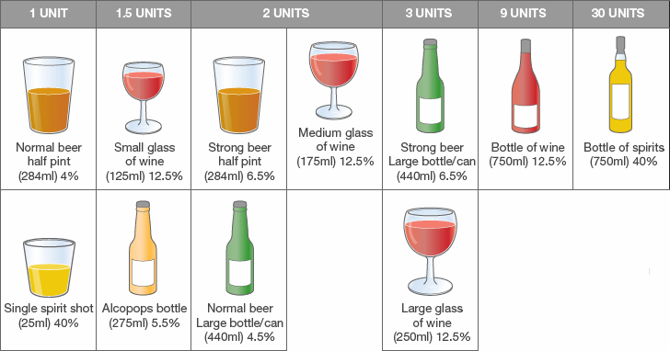

Questions | Scoring System  0 1 2 3 4 |  |  |  |  | Your Score
How often do you have a drink contains alcohol? | Never | Monthly or less | 2-4 times a month | 2-3 times per week | 4+ times per week
How many standard alcohol units do you have on a typical day when you are drinking? | 1-2 | 3-4 | 5-6 | 7-9 | 10+
How often do you have 6 or more standard alcohol units on one occasion? | Never | Less than monthly | Monthly | Weekly | Daily or almost daily
If you score a total of 5 or more on the above questions, please complete the further questions below.
How often in the last year have you found that you were not able to stop drinking once you have started? | Never | Less than monthly | Monthly | Weekly | Daily or almost daily
How often in the last year have you failed to do what was expected of you because of drinking? | Never | Less than monthly | Monthly | Weekly | Daily or almost daily
How often in the last year have you needed an alcoholic drink in the morning to get you going? | Never | Less than monthly | Monthly | Weekly | Daily or almost daily
How often in the last year have you had a feeling of guilt or regret after drinking? | Never | Less than monthly | Monthly | Weekly | Daily or almost daily
How often in the last year have you not been able to remember what happened when drinking the night before? | Never | Less than monthly | Monthly | Weekly | Daily or almost daily
Have you or someone else been injured as a result of your drinking? | No |  | Yes, but not in the last year |  | Yes, during the last year
Has a relative/friend/doctor or health worker been concerned about your drinking or advised you to cut down? | No |  | Yes, but not in the last year |  | Yes, during the last year
Your total score for all ten questions indicates the following:
0-7 = sensible drinking 8-15 = hazardous drinking
16-19 = harmful drinking 20+ = possible dependence
Would you like information or advice about alcohol consumption? YES □ NO□

Forest House Medical Centre
2a Park Drive
L.F.E.
Leicester
LE3 3FN

0116 2898111
Your emergency care summary

Dear Patient

Summary Care Record – your emergency care summary

The NHS in England is introducing the Summary Care Record, which will be used in emergency care.

The record will contain information about any medicines you are taking, allergies you suffer from and any bad reactions to medicines you have had to ensure those caring for you have enough information to treat you safely.

Your Summary Care Record will be available to authorised healthcare staff providing your care anywhere in England, but they will ask your permission before they look at it. This means that
if you have an accident or become ill, healthcare staff treating you will have immediate access to important information about your health.

This practice is supporting Summary Care Records and as a patient you have a choice:

• Yes I would like a Summary Care Record – you do not need to do anything and a Summary Care Record will be created for you.
• No I do not want a Summary Care Record – Please collect an opt-out form from reception

If you need more time to make your choice you should let us know.

For more information please contact the NHS Summary Care Record Information Line on 0300 123 3020., GP practice staff, or visit www.nhscarerecords.nhs.uk.

Additional copies of the opt out form can be collected from the practice, printed from the website www.nhscarerecords.nhs.uk or requested from the dedicated NHS Summary Care Record Information Line on 0300 123 3020.

You can choose not to have a Summary Care Record and you can change your mind at any time by informing your GP practice.

If you do nothing we will assume that you are happy with these changes and create a Summary Care Record for you. Children under 16 will automatically have a Summary Care Record created for them unless their parent or guardian completes an opt out form on their behalf requesting us to consider opting them out. If you are the parent or guardian of a child under 16 and feel that they are old enough to understand, then you should make this information available to them.

Yours sincerely

FOREST HOUSE MEDICAL CENTRE

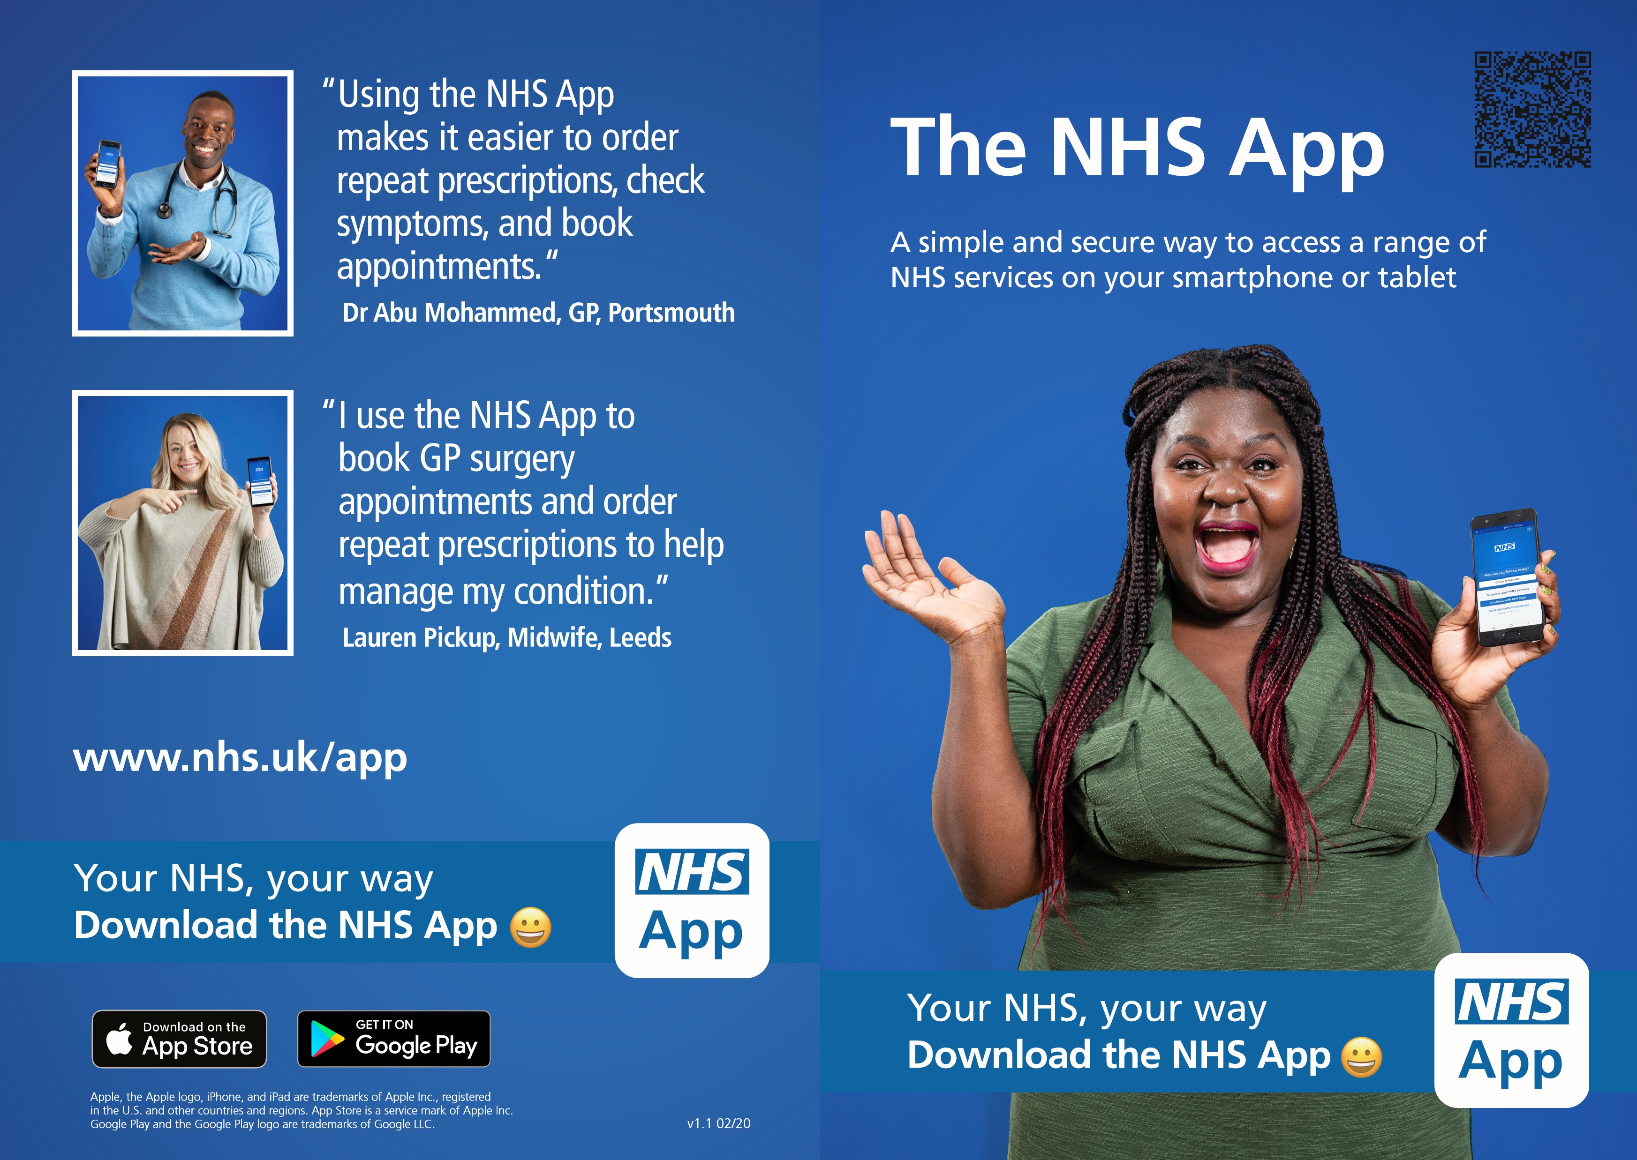
Introducing the NHS App
The NHS App gives you 24/7 access to a range of NHS services.
Use the app to:
- book and cancel appointments - book, view and cancel appointments at your GP surgery
- view your record - access your GP medical record securely
- order repeat prescriptions - see your available medicines and place an order
- check your symptoms - find trusted NHS information on hundreds of conditions and treatments and get instant advice
- register your organ donation decision - choose to donate some or all your organs and check your registered decision
The NHS App gives you more control over your health and care.
Use it wherever you are, at any time of the day or night.
It puts information about your health and treatments at your fingertips. This means you can see it when speaking to a health and care professional, for example.
Owned and run by the NHS
The app is designed and operated by the NHS in England to give you access to a range of services.
We will carefully check your identity when you register for the app, which is secure and easy to use.
The NHS App will not replace existing services. You can still contact your GP surgery in the usual ways if you prefer.

www.nhs.uk/app

